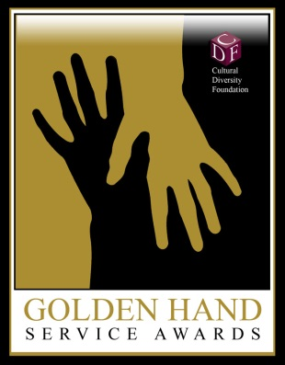
THE 10th ANNIVERSARY GOLDEN HAND SERVICE AWARDS
NOMINATION FORM

The Cultural Diversity Foundation is seeking nominations for the 10th Annual Golden Hand Service Awards.

Golden Hand Service Award
This award honors individuals who have contributed outstanding service to the community by going above and beyond the call of duty to lend a helping hand to someone who was or is in need of support (ex. Educational, Financial, Spiritual, Motivational, Professional, etc.)

Criteria Includes: community service that benefits disadvantaged individuals by significantly making a difference in their lives; A selfless individual who works behind the scenes without seeking the limelight or credit for his or her efforts, while lending credit to others; reaches out to the community or to an individual to help overcome an obstacle without expecting a reward or recognition for their efforts.
Award Categories:

- Business: Honors an individual in the business community who has dedicated their time to lend a helping hand to someone in need
- Community: Honors an individual in the community who has dedicated their time to lend a helping hand to someone in need
- Education: Honors an educator or student in K-12 or higher education who has dedicated their time to lend a helping hand to someone in need
- Philanthropist of the Year: Honors an individual or business that has demonstrated philanthropic leadership in the community

Name of nominee____________________________________________________________
Address____________________________________________________________________
Phone________________________ E-Mail Address________________________________

Nominator (please print)_______________________________________________________
Phone_________________________E-mail Address________________________________
Affiliation with Nominee_______________________________________________________

CONTRIBUTION TO THE LAS VEGAS COMMUNITY:
(Please provide a one-page personal history of the nominee that includes: List of major contributions to the community in support of his or her nomination; explain in detail how the nominee has lended a helping hand and why the nominee should be selected to receive the Golden Hand Service Award.

Submission Deadline: Friday, February 24, 2017, 5:00 p.m. Email Nomination Form to info@cdfnv.org or Fax to 702 221-1901; For more info: Call 702 646-2615
Cultural Diversity Foundation, 500 N. Rainbow Blvd, Suite 300, Las Vegas, NV 89107

